Deployed AWS EKS Cluster using the steps listed here: <https://docs.aws.amazon.com/eks/latest/userguide/getting-started-eksctl.html>

CloudFormation Stack

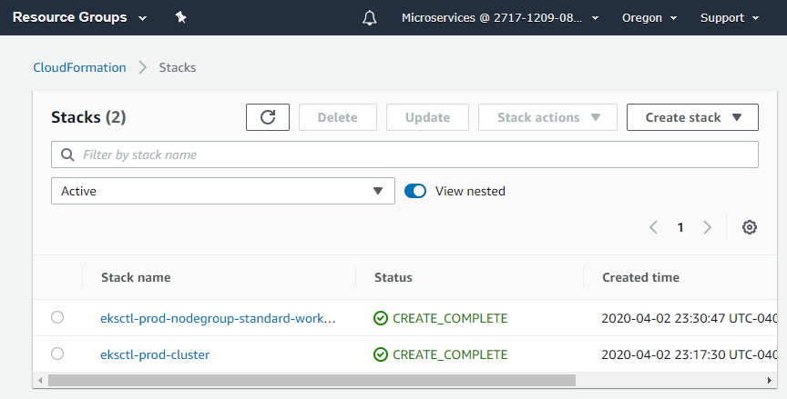  
  
  
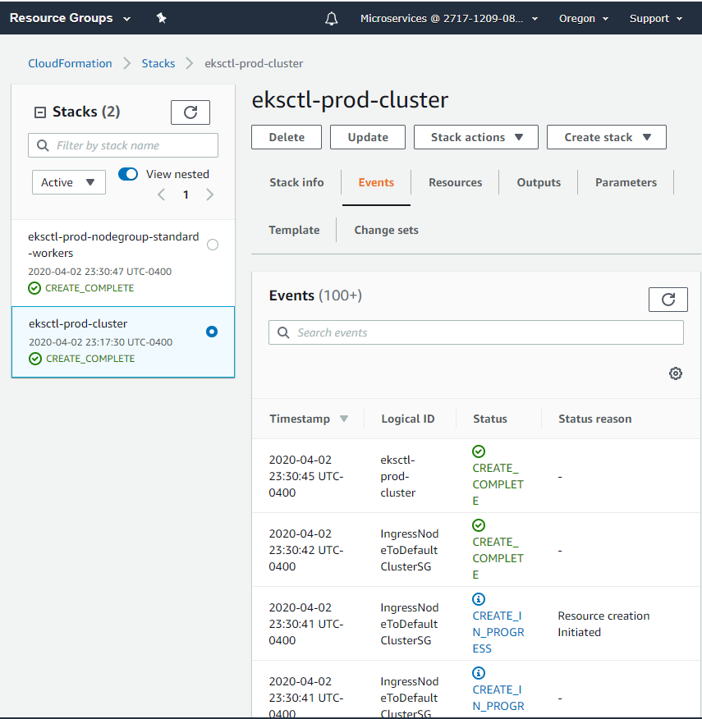

EKS Cluster and Nodes

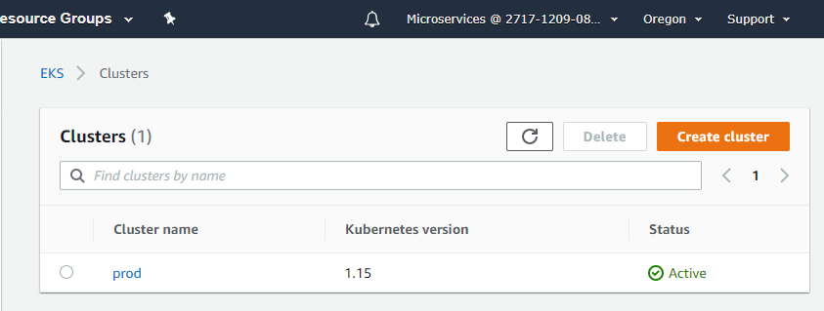

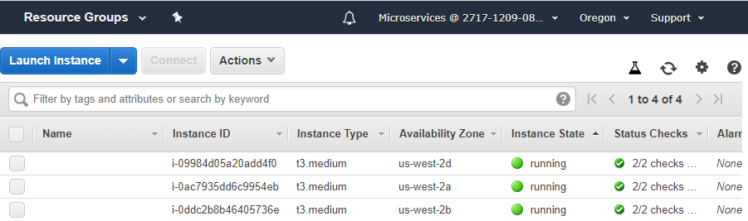

Jenkins Pipeline

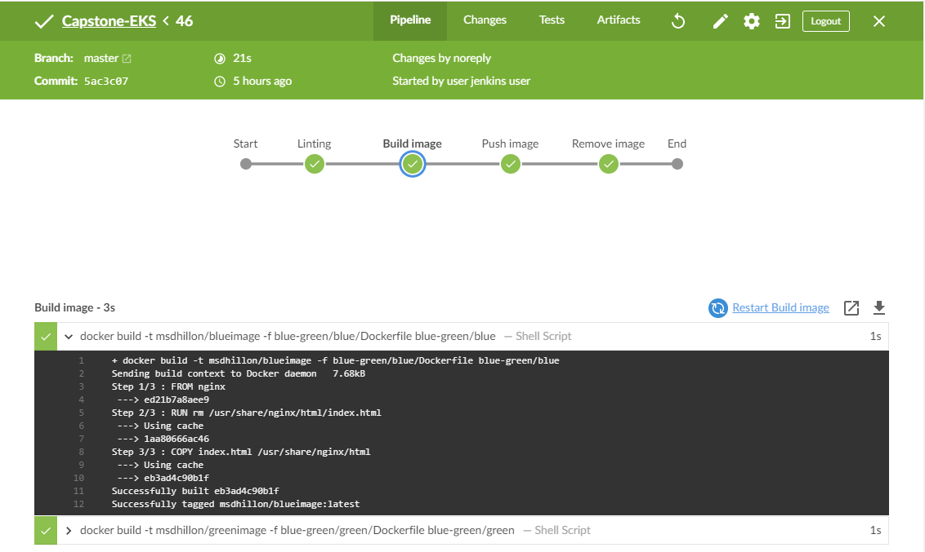

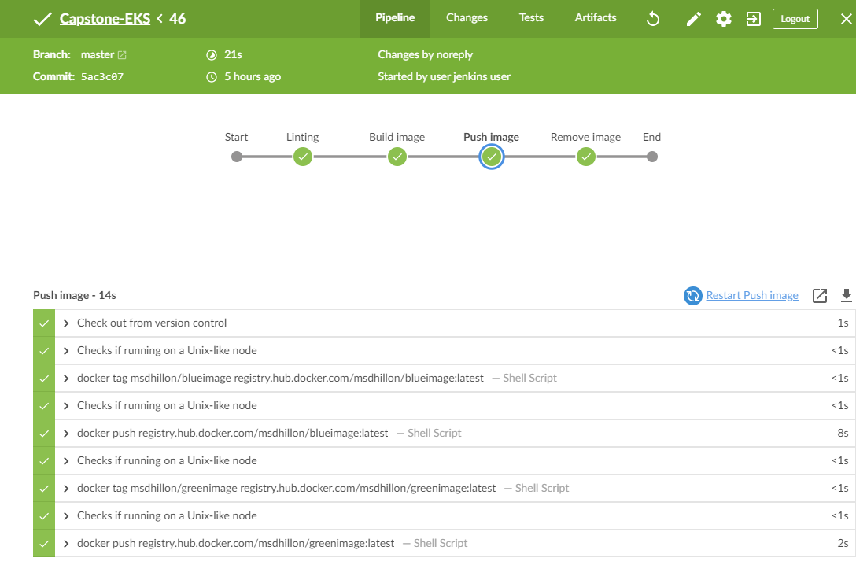

Docker Images uploaded in DockerHub

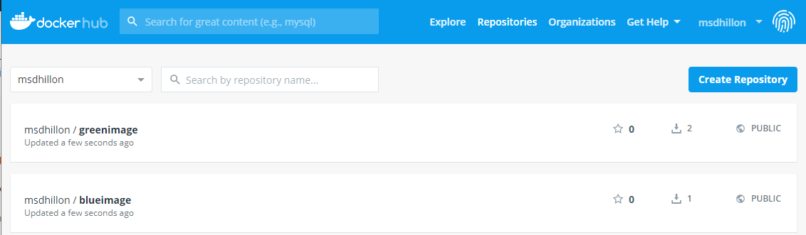

Connecting local machine to EKS  
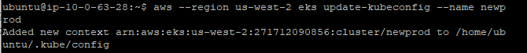

Getting Nodes of EKS Cluster  
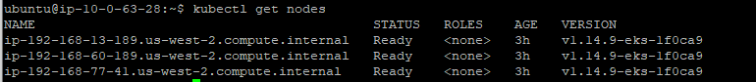

Setting blue-green controller  
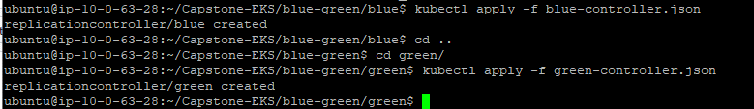

Setting load balancer service type  


Service deployed confirmation  


Blue Deployment confirmation

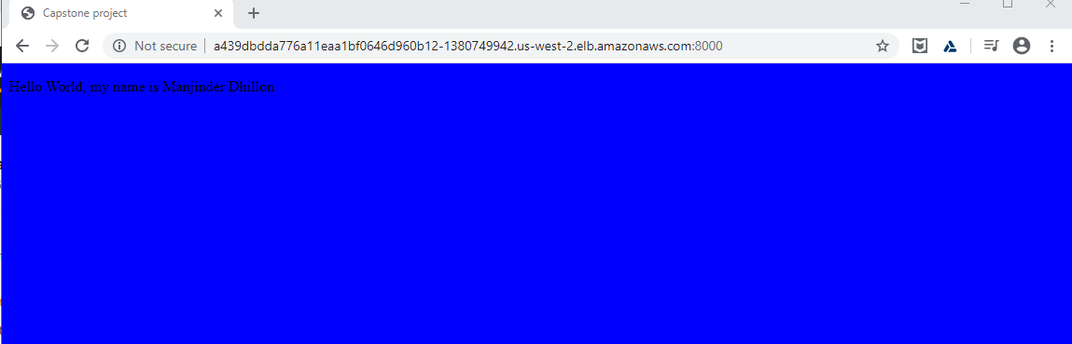

Changing blue-green service to deploy green  
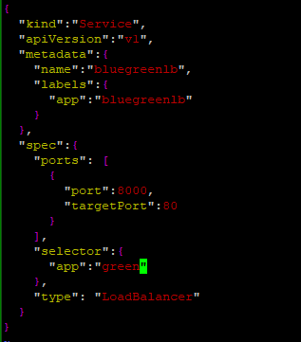

Reapply blue-green-service.json  


Green deployment confirmation

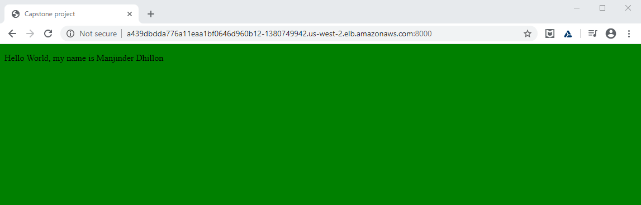

Get Running Pods  
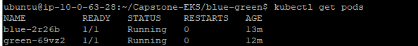

Checking Blue Pod  


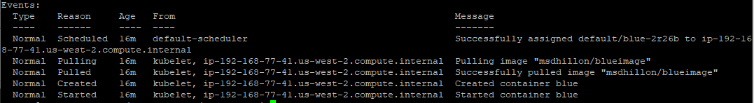

Checking Green Pod  


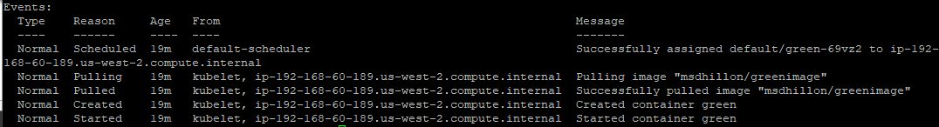

Checking Load Balancer Service  
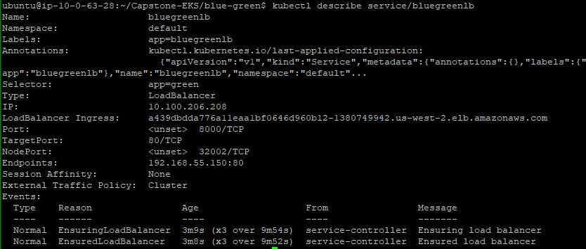  
  
Additional Resources used:  
<https://medium.com/@andresaaap/simple-blue-green-deployment-in-kubernetes-using-minikube-b88907b2e267>